**FSS Unidemensional**

CFA MODEL - ORDINAL

OBSERVED VARIABLES:

F1 F2 F3 F4 F5 F6 F7 F8 F9 F10

Correlation Matrix from File fluir.pcm

Asymptotic Covariance Matrix from File fluir.ACC

Sample Size 882

Latent Variables: F

Relationships:

F1 F2 F3 F4 F5 F6 F7 F8 F9 F10 = F

LISREL Output: ND=3 SC ME=DWLS

Path Diagram

End of Problem

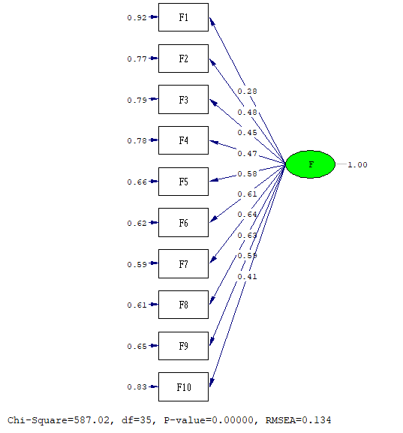

Goodness of Fit Statistics

Degrees of Freedom = 35

Normal Theory Weighted Least Squares Chi-Square = 912.489 (P = 0.0)

Satorra-Bentler Scaled Chi-Square = 587.023 (P = 0.0)

Chi-Square Corrected for Non-Normality = 367.860 (P = 0.0)

Estimated Non-centrality Parameter (NCP) = 552.023

90 Percent Confidence Interval for NCP = (477.187 ; 634.286)

Minimum Fit Function Value = 0.482

Population Discrepancy Function Value (F0) = 0.627

90 Percent Confidence Interval for F0 = (0.542 ; 0.720)

Root Mean Square Error of Approximation (RMSEA) = 0.134

90 Percent Confidence Interval for RMSEA = (0.124 ; 0.143)

P-Value for Test of Close Fit (RMSEA < 0.05) = 0.000

Expected Cross-Validation Index (ECVI) = 0.712

90 Percent Confidence Interval for ECVI = (0.627 ; 0.805)

ECVI for Saturated Model = 0.125

ECVI for Independence Model = 3.610

Chi-Square for Independence Model with 45 Degrees of Freedom = 3160.791

Independence AIC = 3180.791

Model AIC = 627.023

Saturated AIC = 110.000

Independence CAIC = 3238.612

Model CAIC = 742.666

Saturated CAIC = 428.021

Normed Fit Index (NFI) = 0.814

Non-Normed Fit Index (NNFI) = 0.772

Parsimony Normed Fit Index (PNFI) = 0.633

Comparative Fit Index (CFI) = 0.823

Incremental Fit Index (IFI) = 0.823

Relative Fit Index (RFI) = 0.761

Critical N (CN) = 87.059

Root Mean Square Residual (RMR) = 0.0979

Standardized RMR = 0.0979

Goodness of Fit Index (GFI) = 0.943

Adjusted Goodness of Fit Index (AGFI) = 0.910

Parsimony Goodness of Fit Index (PGFI) = 0.600

**FSS Unidemensional – Covarianza x1**

CFA MODEL - ORDINAL

OBSERVED VARIABLES:

F1 F2 F3 F4 F5 F6 F7 F8 F9 F10

Correlation Matrix from File fluir.pcm

Asymptotic Covariance Matrix from File fluir.ACC

Sample Size 882

Latent Variables: F

Relationships:

F1 F2 F3 F4 F5 F6 F7 F8 F9 F10 = F

LISREL Output: ND=3 SC ME=DWLS

Set the Error Covariance of F8 and F9

Path Diagram

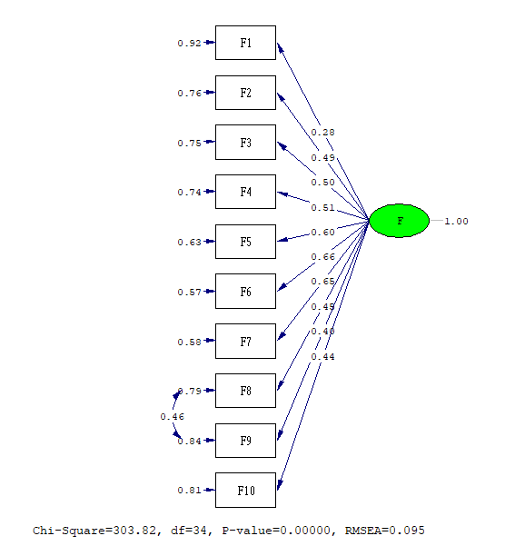

Goodness of Fit Statistics

Degrees of Freedom = 34

Normal Theory Weighted Least Squares Chi-Square = 471.482 (P = 0.0)

Satorra-Bentler Scaled Chi-Square = 303.816 (P = 0.0)

Chi-Square Corrected for Non-Normality = 254.919 (P = 0.0)

Estimated Non-centrality Parameter (NCP) = 269.816

90 Percent Confidence Interval for NCP = (217.787 ; 329.314)

Minimum Fit Function Value = 0.275

Population Discrepancy Function Value (F0) = 0.306

90 Percent Confidence Interval for F0 = (0.247 ; 0.374)

Root Mean Square Error of Approximation (RMSEA) = 0.0949

90 Percent Confidence Interval for RMSEA = (0.0853 ; 0.105)

P-Value for Test of Close Fit (RMSEA < 0.05) = 0.000

Expected Cross-Validation Index (ECVI) = 0.393

90 Percent Confidence Interval for ECVI = (0.333 ; 0.460)

ECVI for Saturated Model = 0.125

ECVI for Independence Model = 3.610

Chi-Square for Independence Model with 45 Degrees of Freedom = 3160.791

Independence AIC = 3180.791

Model AIC = 345.816

Saturated AIC = 110.000

Independence CAIC = 3238.612

Model CAIC = 467.242

Saturated CAIC = 428.021

Normed Fit Index (NFI) = 0.904

Non-Normed Fit Index (NNFI) = 0.885

Parsimony Normed Fit Index (PNFI) = 0.683

Comparative Fit Index (CFI) = 0.913

Incremental Fit Index (IFI) = 0.914

Relative Fit Index (RFI) = 0.873

Critical N (CN) = 163.566

Root Mean Square Residual (RMR) = 0.0772

Standardized RMR = 0.0772

Goodness of Fit Index (GFI) = 0.967

Adjusted Goodness of Fit Index (AGFI) = 0.947

Parsimony Goodness of Fit Index (PGFI) = 0.598

**FSS Unidemensional – Covarianza x2**

CFA MODEL - ORDINAL

OBSERVED VARIABLES:

F1 F2 F3 F4 F5 F6 F7 F8 F9 F10

Correlation Matrix from File fluir.pcm

Asymptotic Covariance Matrix from File fluir.ACC

Sample Size 882

Latent Variables: F

Relationships:

F1 F2 F3 F4 F5 F6 F7 F8 F9 F10 = F

LISREL Output: ND=3 SC ME=DWLS

Set the Error Covariance of F7 and F8

Set the Error Covariance of F8 and F9

Path Diagram

End of Problem

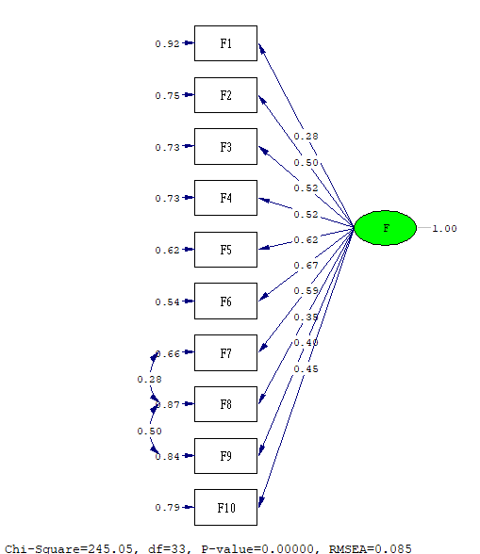

Goodness of Fit Statistics

Degrees of Freedom = 33

Normal Theory Weighted Least Squares Chi-Square = 391.229 (P = 0.0)

Satorra-Bentler Scaled Chi-Square = 245.055 (P = 0.0)

Chi-Square Corrected for Non-Normality = 216.036 (P = 0.0)

Estimated Non-centrality Parameter (NCP) = 212.055

90 Percent Confidence Interval for NCP = (166.010 ; 265.586)

Minimum Fit Function Value = 0.220

Population Discrepancy Function Value (F0) = 0.241

90 Percent Confidence Interval for F0 = (0.188 ; 0.301)

Root Mean Square Error of Approximation (RMSEA) = 0.0854

90 Percent Confidence Interval for RMSEA = (0.0756 ; 0.0956)

P-Value for Test of Close Fit (RMSEA < 0.05) = 0.000

Expected Cross-Validation Index (ECVI) = 0.328

90 Percent Confidence Interval for ECVI = (0.276 ; 0.389)

ECVI for Saturated Model = 0.125

ECVI for Independence Model = 3.610

Chi-Square for Independence Model with 45 Degrees of Freedom = 3160.791

Independence AIC = 3180.791

Model AIC = 289.055

Saturated AIC = 110.000

Independence CAIC = 3238.612

Model CAIC = 416.263

Saturated CAIC = 428.021

Normed Fit Index (NFI) = 0.922

Non-Normed Fit Index (NNFI) = 0.907

Parsimony Normed Fit Index (PNFI) = 0.676

Comparative Fit Index (CFI) = 0.932

Incremental Fit Index (IFI) = 0.932

Relative Fit Index (RFI) = 0.894

Critical N (CN) = 197.925

Root Mean Square Residual (RMR) = 0.0702

Standardized RMR = 0.0702

Goodness of Fit Index (GFI) = 0.974

Adjusted Goodness of Fit Index (AGFI) = 0.957

Parsimony Goodness of Fit Index (PGFI) = 0.584

**FSS Bidimensional**

CFA MODEL - ORDINAL

OBSERVED VARIABLES:

F1 F2 F3 F4 F5 F6 F7 F8 F9 F10

Correlation Matrix from File fluir.pcm

Asymptotic Covariance Matrix from File fluir.ACC

Sample Size 882

Latent Variables: A F

Relationships:

F1 F3 F6 F10 = A

F2 F4 F5 F7 F8 F9 = F

LISREL Output: ND=3 SC ME=DWLS

Path Diagram

End of Problem

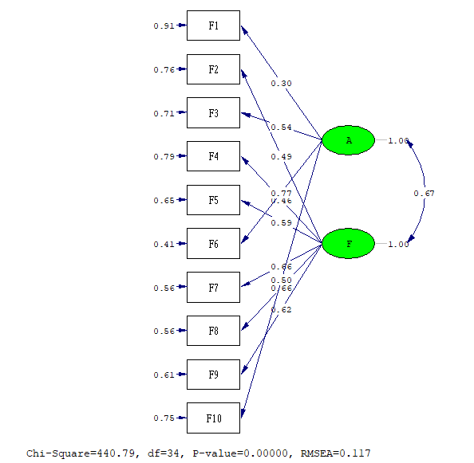

Goodness of Fit Statistics

Degrees of Freedom = 34

Normal Theory Weighted Least Squares Chi-Square = 688.588 (P = 0.0)

Satorra-Bentler Scaled Chi-Square = 440.795 (P = 0.0)

Chi-Square Corrected for Non-Normality = 297.458 (P = 0.0)

Estimated Non-centrality Parameter (NCP) = 406.795

90 Percent Confidence Interval for NCP = (342.752 ; 478.284)

Minimum Fit Function Value = 0.402

Population Discrepancy Function Value (F0) = 0.462

90 Percent Confidence Interval for F0 = (0.389 ; 0.543)

Root Mean Square Error of Approximation (RMSEA) = 0.117

90 Percent Confidence Interval for RMSEA = (0.107 ; 0.126)

P-Value for Test of Close Fit (RMSEA < 0.05) = 0.000

Expected Cross-Validation Index (ECVI) = 0.548

90 Percent Confidence Interval for ECVI = (0.475 ; 0.629)

ECVI for Saturated Model = 0.125

ECVI for Independence Model = 3.610

Chi-Square for Independence Model with 45 Degrees of Freedom = 3160.791

Independence AIC = 3180.791

Model AIC = 482.795

Saturated AIC = 110.000

Independence CAIC = 3238.612

Model CAIC = 604.221

Saturated CAIC = 428.021

Normed Fit Index (NFI) = 0.861

Non-Normed Fit Index (NNFI) = 0.827

Parsimony Normed Fit Index (PNFI) = 0.650

Comparative Fit Index (CFI) = 0.869

Incremental Fit Index (IFI) = 0.870

Relative Fit Index (RFI) = 0.815

Critical N (CN) = 113.048

Root Mean Square Residual (RMR) = 0.0901

Standardized RMR = 0.0901

Goodness of Fit Index (GFI) = 0.952

Adjusted Goodness of Fit Index (AGFI) = 0.923

Parsimony Goodness of Fit Index (PGFI) = 0.589

**FSS Bidimensional – Covarianza x1**

CFA MODEL - ORDINAL

OBSERVED VARIABLES:

F1 F2 F3 F4 F5 F6 F7 F8 F9 F10

Correlation Matrix from File fluir.pcm

Asymptotic Covariance Matrix from File fluir.ACC

Sample Size 882

Latent Variables: A F

Relationships:

F1 F3 F6 F10 = A

F2 F4 F5 F7 F8 F9 = F

LISREL Output: ND=3 SC ME=DWLS

Set the Error Covariance of F8 and F9

Path Diagram

End of Problem

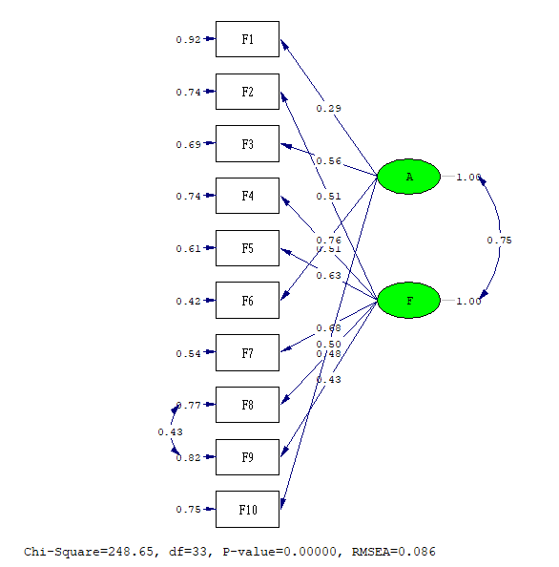

Goodness of Fit Statistics

Degrees of Freedom = 33

Normal Theory Weighted Least Squares Chi-Square = 387.453 (P = 0.0)

Satorra-Bentler Scaled Chi-Square = 248.653 (P = 0.0)

Chi-Square Corrected for Non-Normality = 214.336 (P = 0.0)

Estimated Non-centrality Parameter (NCP) = 215.653

90 Percent Confidence Interval for NCP = (169.217 ; 269.573)

Minimum Fit Function Value = 0.231

Population Discrepancy Function Value (F0) = 0.245

90 Percent Confidence Interval for F0 = (0.192 ; 0.306)

Root Mean Square Error of Approximation (RMSEA) = 0.0861

90 Percent Confidence Interval for RMSEA = (0.0763 ; 0.0963)

P-Value for Test of Close Fit (RMSEA < 0.05) = 0.000

Expected Cross-Validation Index (ECVI) = 0.332

90 Percent Confidence Interval for ECVI = (0.279 ; 0.393)

ECVI for Saturated Model = 0.125

ECVI for Independence Model = 3.610

Chi-Square for Independence Model with 45 Degrees of Freedom = 3160.791

Independence AIC = 3180.791

Model AIC = 292.653

Saturated AIC = 110.000

Independence CAIC = 3238.612

Model CAIC = 419.861

Saturated CAIC = 428.021

Normed Fit Index (NFI) = 0.921

Non-Normed Fit Index (NNFI) = 0.906

Parsimony Normed Fit Index (PNFI) = 0.676

Comparative Fit Index (CFI) = 0.931

Incremental Fit Index (IFI) = 0.931

Relative Fit Index (RFI) = 0.893

Critical N (CN) = 195.076

Root Mean Square Residual (RMR) = 0.0709

Standardized RMR = 0.0709

Goodness of Fit Index (GFI) = 0.973

Adjusted Goodness of Fit Index (AGFI) = 0.954

Parsimony Goodness of Fit Index (PGFI) = 0.584

**FSS Bidimensional – Covarianza x2**

CFA MODEL - ORDINAL

OBSERVED VARIABLES:

F1 F2 F3 F4 F5 F6 F7 F8 F9 F10

Correlation Matrix from File fluir.pcm

Asymptotic Covariance Matrix from File fluir.ACC

Sample Size 882

Latent Variables: A F

Relationships:

F1 F3 F6 F10 = A

F2 F4 F5 F7 F8 F9 = F

LISREL Output: ND=3 SC ME=DWLS

Set the Error Covariance of F7 and F8

Set the Error Covariance of F8 and F9

Path Diagram

End of Problem

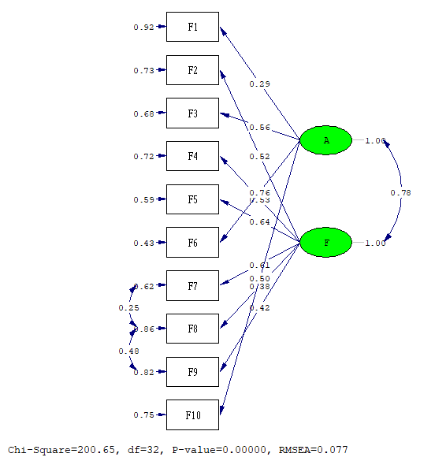

Goodness of Fit Statistics

Degrees of Freedom = 32

Normal Theory Weighted Least Squares Chi-Square = 318.355 (P = 0.0)

Satorra-Bentler Scaled Chi-Square = 200.655 (P = 0.0)

Chi-Square Corrected for Non-Normality = 181.066 (P = 0.0)

Estimated Non-centrality Parameter (NCP) = 168.655

90 Percent Confidence Interval for NCP = (127.644 ; 217.168)

Minimum Fit Function Value = 0.189

Population Discrepancy Function Value (F0) = 0.191

90 Percent Confidence Interval for F0 = (0.145 ; 0.247)

Root Mean Square Error of Approximation (RMSEA) = 0.0773

90 Percent Confidence Interval for RMSEA = (0.0673 ; 0.0878)

P-Value for Test of Close Fit (RMSEA < 0.05) = 0.000

Expected Cross-Validation Index (ECVI) = 0.280

90 Percent Confidence Interval for ECVI = (0.233 ; 0.335)

ECVI for Saturated Model = 0.125

ECVI for Independence Model = 3.610

Chi-Square for Independence Model with 45 Degrees of Freedom = 3160.791

Independence AIC = 3180.791

Model AIC = 246.655

Saturated AIC = 110.000

Independence CAIC = 3238.612

Model CAIC = 379.645

Saturated CAIC = 428.021

Normed Fit Index (NFI) = 0.937

Non-Normed Fit Index (NNFI) = 0.924

Parsimony Normed Fit Index (PNFI) = 0.666

Comparative Fit Index (CFI) = 0.946

Incremental Fit Index (IFI) = 0.946

Relative Fit Index (RFI) = 0.911

Critical N (CN) = 235.854

Root Mean Square Residual (RMR) = 0.0649

Standardized RMR = 0.0649

Goodness of Fit Index (GFI) = 0.978

Adjusted Goodness of Fit Index (AGFI) = 0.961

Parsimony Goodness of Fit Index (PGFI) = 0.569

**IMPORTANCIA PERCIBIDA**

CFA MODEL - ORDINAL

OBSERVED VARIABLES:

IMP11 IMP12 IMP13

Correlation Matrix from File imp.PCM

Asymptotic Covariance Matrix from File imp.ACC

Sample Size 882

Latent Variables: IMP

Relationships:

IMP11 IMP12 IMP13 = IMP

LISREL Output: ND=3 SC ME=DWLS

Path Diagram

End of Problem

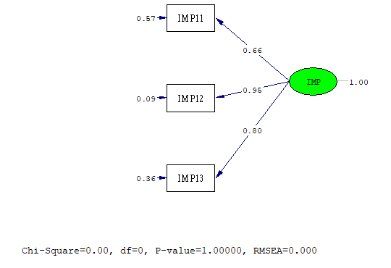

Goodness of Fit Statistics

Degrees of Freedom = 0

Normal Theory Weighted Least Squares Chi-Square = 0.0 (P = 1.000)

Satorra-Bentler Scaled Chi-Square = 0.0 (P = 1.000)

The Model is Saturated, the Fit is Perfect !